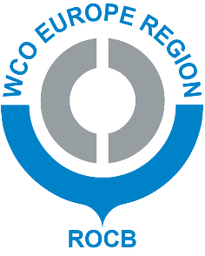
ROCB EUROPE WEB SITE MEMBERS ONLY SECTION ACCESS FORM
Please complete this form and send it to ROCB Europe via email: info@rocb-europe.org
Family name:
First name:
Email address*:
Title:
Organization:
Address:
Country:
Language desired for correspondence
(English or Russian):
Password requested:
Signature of requester:
Signature of director general or representative:
Organization stamp:
*only email addresses with extensions such as .edu, .gov, .org will be considered for membership.

